20
10
8
6
4
2
12
14
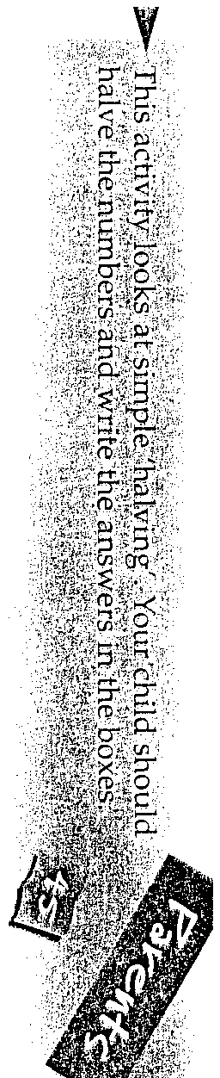
(0
(/1
ru
(0

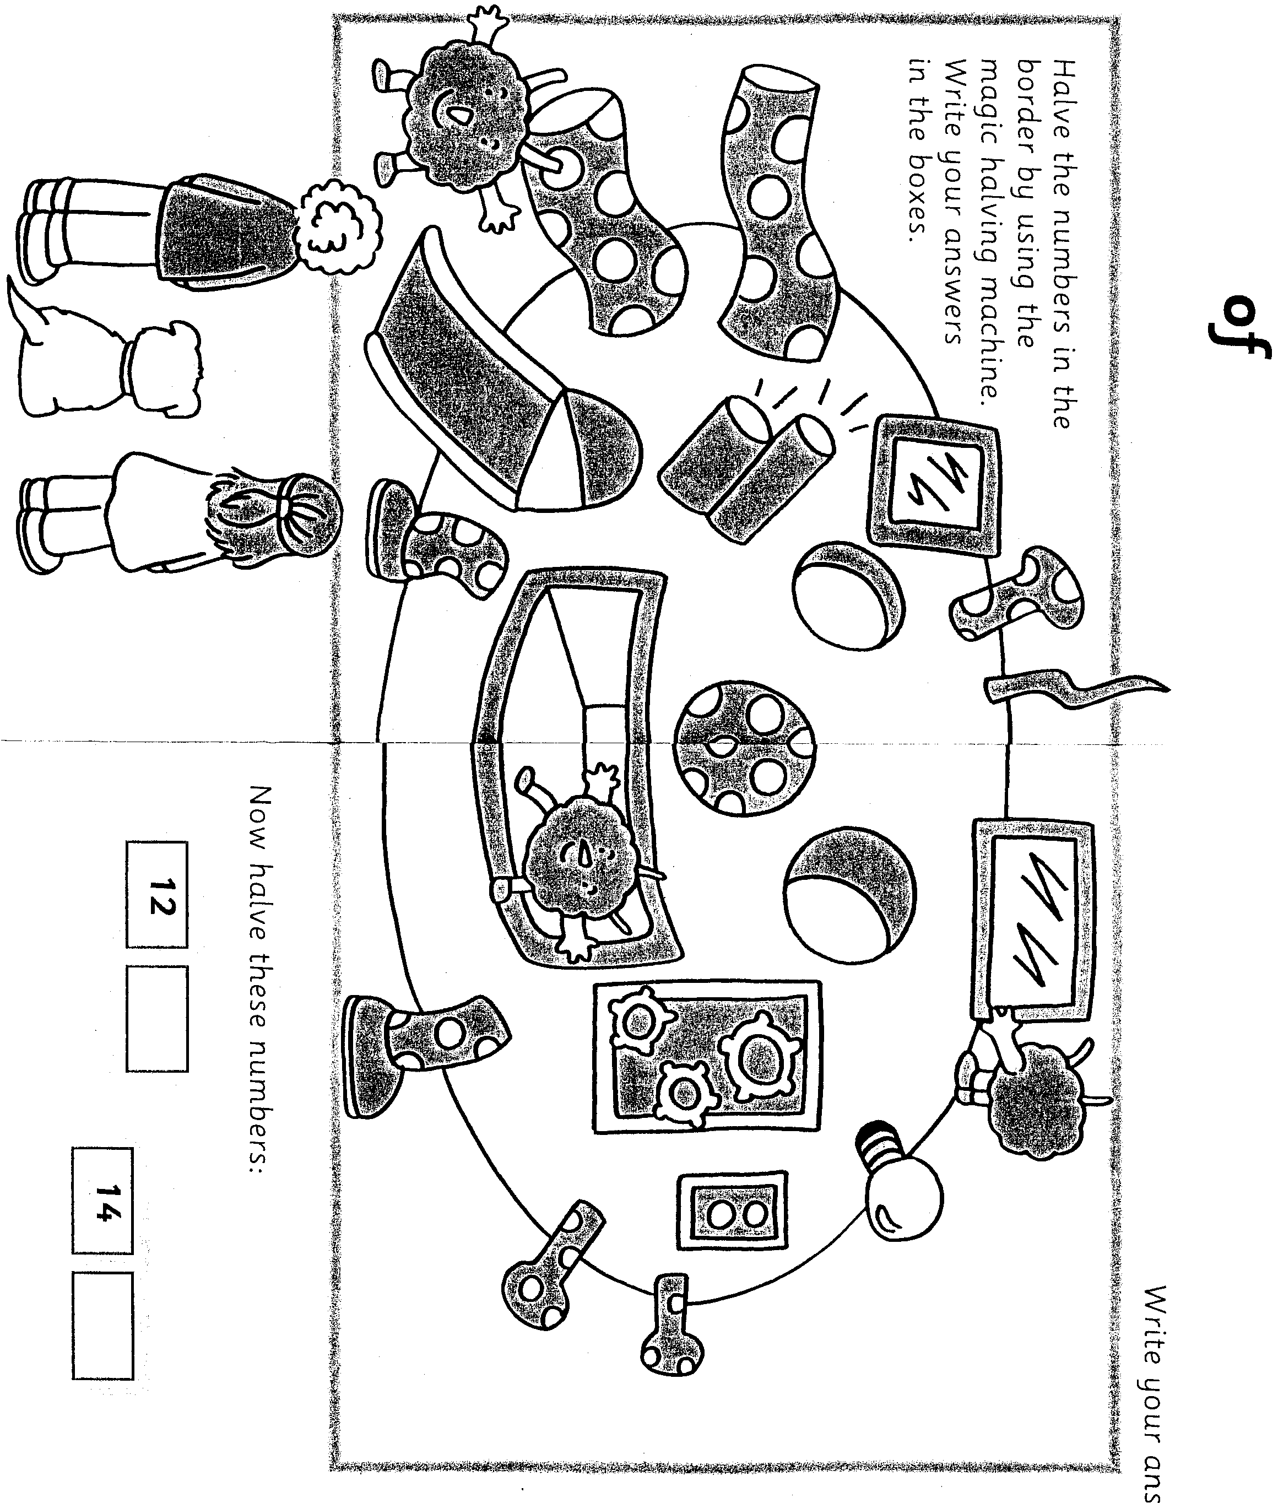

Halves of quantities.
10
Write your answers here :
16
18

