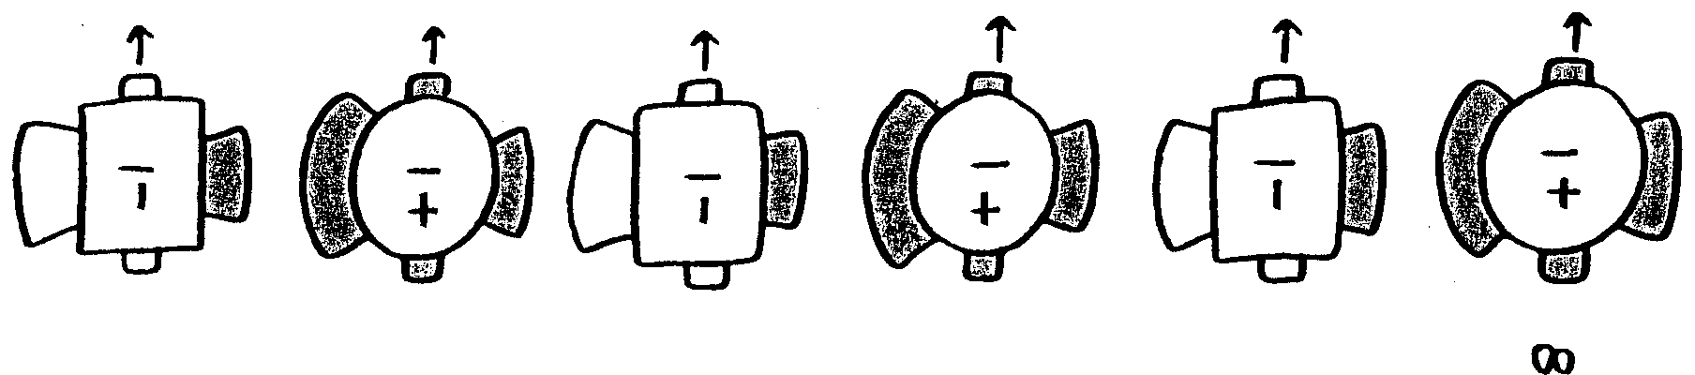
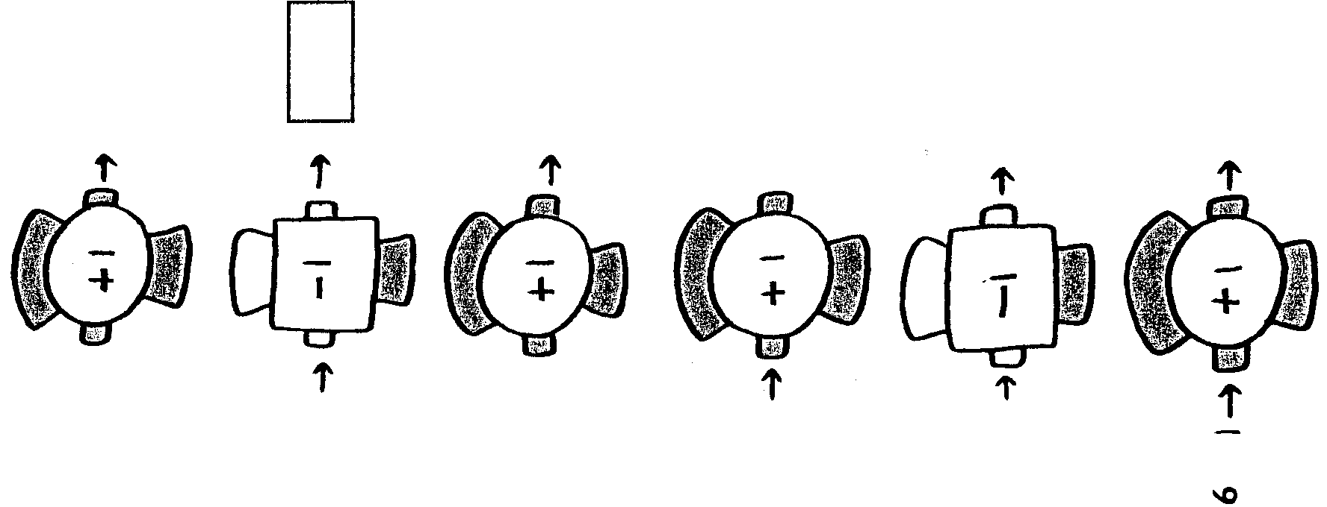
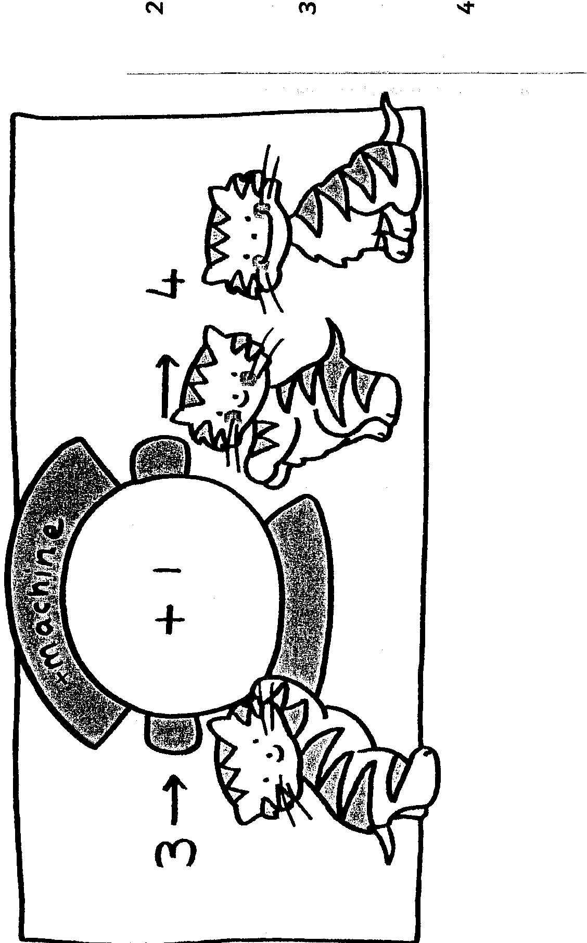
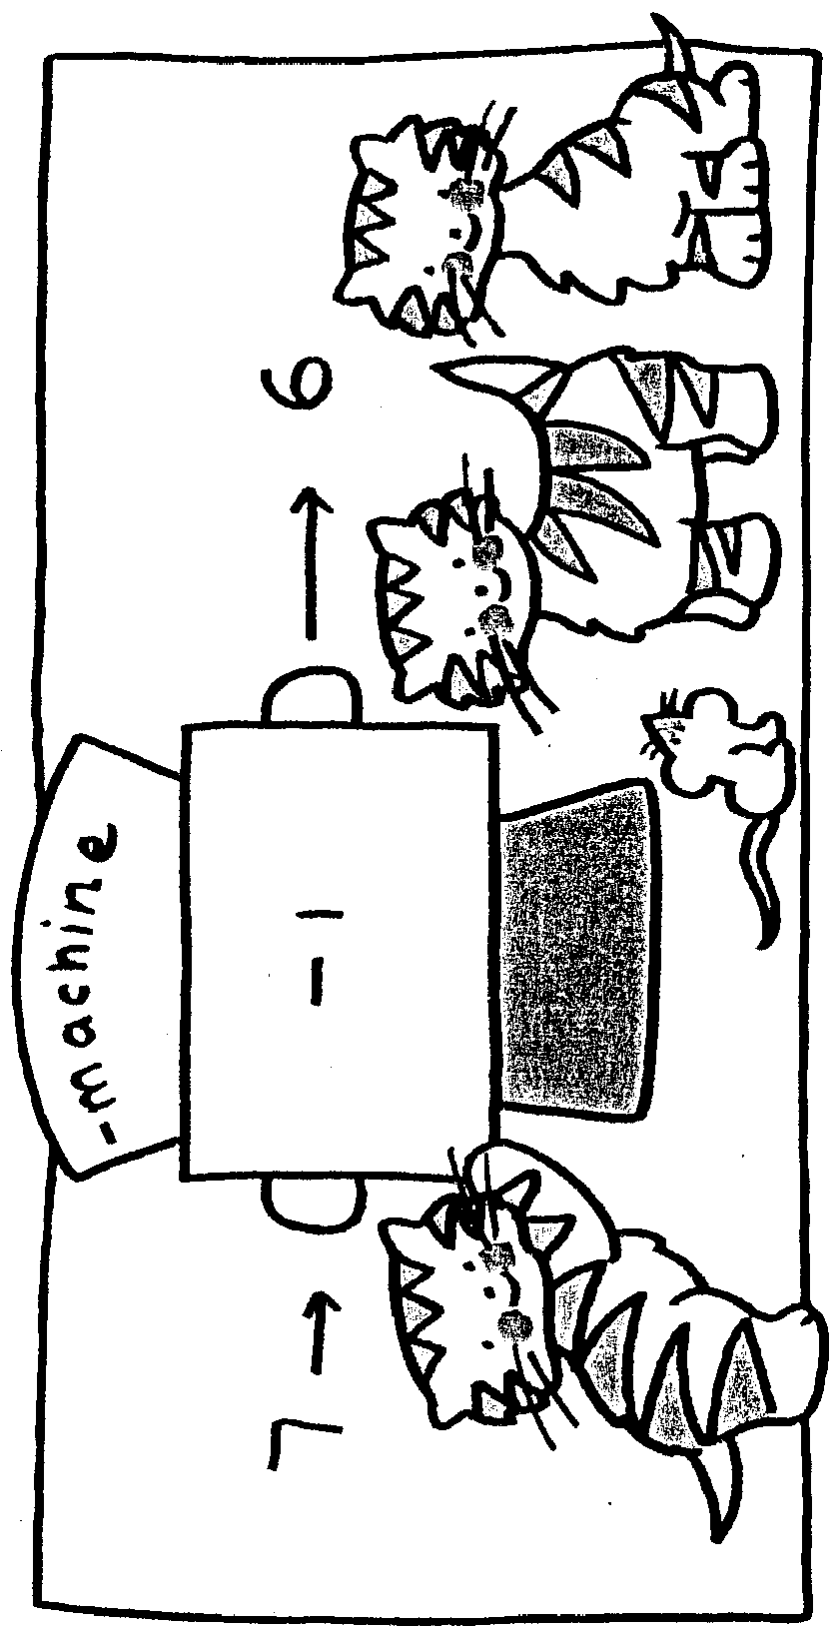

7
8
9
10
11
12
1
2
3
4
5
6
Add and subtract 1.
Use the +1 & -1 machines to work out the answers.

