Write a sentence in Chinese.

I am (your name)

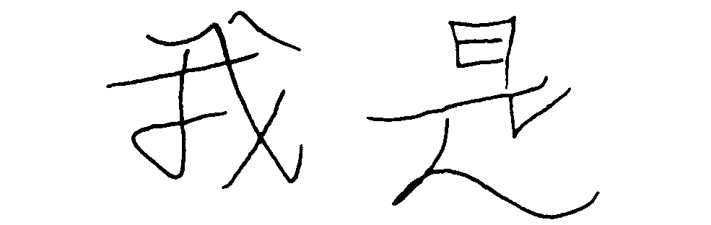
I am

