Chinese Lanterns
Make Chinese lanterns to decorate your classroom Cut slits into a rectangle of coloured paper. Fold and glue it into a cylindrical shape, staple on a handle and suspend it from the ceiling. Tissue paper can be fixed to the inside to make the lantern glow.
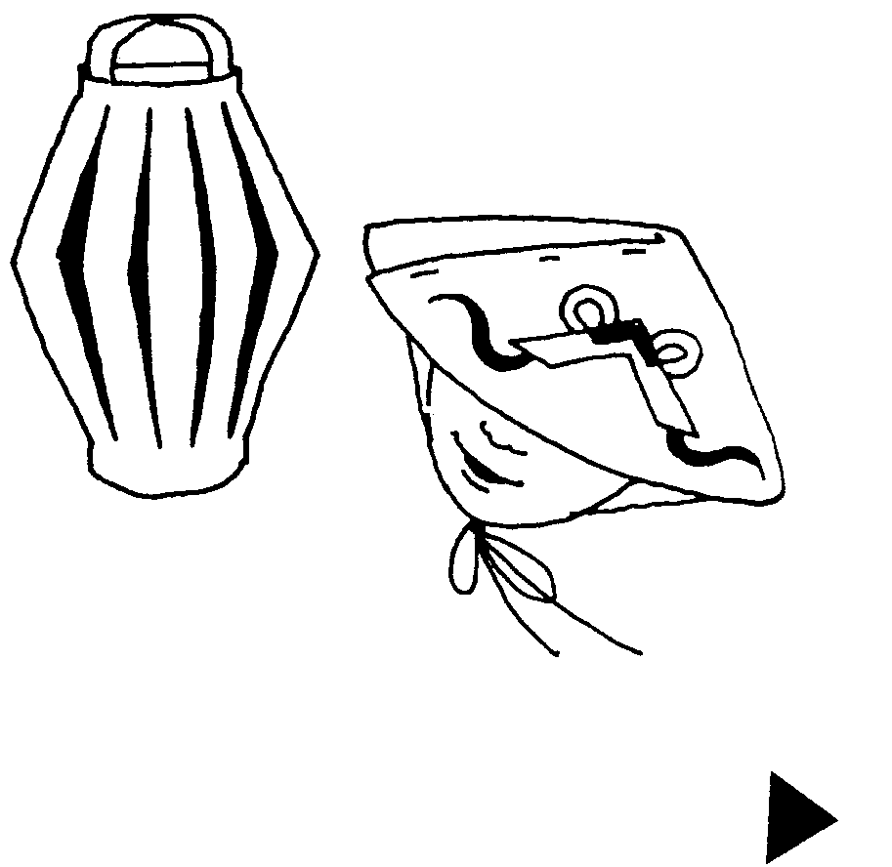

Chinese hats
Make Chinese style hats for the children to wear for a new year party or lesson. Cut large circles of thin card with one slit to the centre. The children can decorate these with Chinese symbols or pictures, then fold and staple them into a hat shape. Attach pieces of ribbon or elastic to secure the hat under the owner’s chin.

